A FIELD PROJECT REPORT ON

**E-COMMERCE WEBSITE**

Submitted in partial fulfilment of the requirements for the award of the degree

**BACHELOR OF TECHNOLOGY**

in

**COMPUTER SCIENCE AND ENGINEERING**

Submitted by

|  |  |
| --- | --- |
| A. Naga babu | (231FAO4063) |
| M. Pavan Kumar Reddy | (231FA04633) |
| B. Bhargav | (231FA04A43) |
| B. Ganesh | (231FA04C10) |
|  |  |



Department of **COMPUTER SCIENCE AND ENGINEERING**

School of YYYYYYYYYYYYYYYY

Vignan’s Foundation for Science, Technology and Research (Deemed to be University) Vadlamudi, Guntur, Andhra Pradesh-522213, India

**MARCH-2025**



**CERTIFICATE**

This is to certify that the field project entitled “**E-COMMERCE WEBSITE**” being submitted by (A. Naga babu 231FAO4063), (M. Pavan Kumar Reddy 231FA04633), (B. Bhargav,231FA04A43), and (B.Ganesh 231FA04C10) in partial fulfilment of Bachelor of Technology in the Department of COMPUTER SCIENCE AND ENGINEERING, Vignan’s Foundation For Science Technology & Research (Deemed to be University), Vadlamudi, Guntur District, Andhra Pradesh, India, is a bonafide work carried out by them under my guidance and supervision.

|  |  |
| --- | --- |
| **Head of the Department** | **Guide** |

**DECLARATION**

We hereby declare that our project work described in the field project titled “E-COMMERCE” which is being submitted by us for the partial fulfilment in the department of COMPUTER SCIENCE AND ENGINEERING, Vignan’s Foundation for Science, Technology and Research (Deemed to be University), Vadlamudi, Guntur, Andhra Pradesh, and the result of investigations are carried out by us under the guidance of (Name of the Guide)

|  |  |
| --- | --- |
| A. Naga babu | (231FAO4063) |
| M. Pavan Kumar Reddy | (231FA04633) |
| B. Bhargav | (231FA04A43) |
| B. Ganesh | (231FA04C10) |

**Contents**

|  |  |  |
| --- | --- | --- |
| **Chapter No.** | **Description** | **Page No.** |
|  | **Introduction** |  |
|  | **Abstract** |  |
|  | **Components** |  |
|  | **Literary Survey** |  |
|  | **Output** |  |
|  | **Conclusion** |  |
|  | **References** |  |

|  |
| --- |
|  |

**E-COMMERCE**

|  |  |  |  |
| --- | --- | --- | --- |
| A. Naga babu | M. Pavan Kumar Reddy | B. Bhargav | B. Ganesh |
| 231FAO4063 | 231FA04633 | 231FA04A43 | 231FA04c10 |
| CSE | CSE | CSE | CSE |
| VIGNAN UNIVERSITY | VIGNAN UNIVERSITY | VIGNAN UNIVERSITY | VIGNAN UNIVERSITY |

**Abstract—**E-commerce platforms have revolutionized the way businesses and consumers interact, enabling seamless buying and selling of goods and services over the internet. This paper explores the architecture, functionality, and technological advancements driving modern e-commerce systems. The platform leverages scalable cloud infrastructure, intuitive user interfaces, and secure payment gateways to enhance user experience and operational efficiency. Key features include personalized recommendations powered by AI, advanced inventory management, multi-channel integration, and robust data analytics for decision-making. The study also addresses challenges like cybersecurity, data privacy, and logistics, offering solutions to create a sustainable and customer-centric e-commerce ecosystem. This work aims to provide insights into the current trends and future potential of e-commerce in a digitally connected world.

# **Introduction**

E-commerce has revolutionized the way businesses operate, enabling seamless buying and selling of goods and services online. By leveraging advancements in technology, such as secure payment gateways, AI-driven personalization, and cloud computing, e-commerce platforms have made shopping more accessible, convenient, and efficient for consumers worldwide. These platforms connect sellers with a global audience, offering diverse products and services across industries. However, challenges like cybersecurity, logistics, and intense competition require continuous innovation. This paper explores the fundamental components, benefits, and challenges of e-commerce, highlighting its transformative impact on modern business and consumer behavior.

# **Problem Statement**

Developing a scalable and user - friendly

e-commerce platform that delivers personalized shopping experiences, seamless integrations, and robust security while remaining cost-effective for businesses.

# **Motivation**

**1.Goal Setting**: Establishing clear and achievable goals gives a sense of direction and purpose.

**2.Personal Growth**: Motivation drives learning, skill development, and self-improvement.

**3.Rewards and Recognition**: Acknowledgment of efforts boosts morale and inspires continued

efforts.

**4.Passion and Interest**: Being passionate about a task or subject naturally fuels motivation.

**5.Challenges**: Overcoming obstacles fosters resilience and sense of accomplishment.

**6.External Encouragement**: Support and encouragement from others can reignite drive and focus.

**7.Visualization**: Imagining success and its benefits reinforces determination to achieve it.

# **Existing system**

1.User Features: User registration, login, and profile management. Browsing and searching products with advanced filters. Adding items to the shopping cart and wish list. Secure payment options and real-time order tracking.

2.Admin Features: Managing product inventory, categories, and pricing. Viewing and analyzing sales data and customer behavior. Handling user accounts, reviews, and complaints

3.Additional0Features:Personalized0product0recommendati-ons based on browsing history Discount coupons and promotional campaigns. Support for multiple languages and currencies. Integration with social media platforms for marketing and login options.

|  |  |
| --- | --- |
| **Component** | **Technology** |
| Database | MySQL |
| Front-End | HTML, CSS,  JavaScript |
| Back-End | Java Script |

# **Components**

# **ADVANTAGES**

**For Businesses:**

* **Global Reach**: Businesses can reach customers across the world, breaking geographical barriers.
* **Lower Operating Costs**: Reduced need for physical stores, staff, and utilities, leading to significant cost savings.
* **24/7 Availability**: Online stores remain open around the clock, increasing potential sales opportunities.

**For Consumers:**

* **Convenience**: Customers can shop anytime, anywhere, without the need to visit a physical store.
* **Wide Variety**: Access to a broader range of products and services, often with better price comparisons.
* **Better Prices**: E-commerce often eliminates middlemen, resulting in more competitive prices.

# **DISADVANTAGES**

**For Businesses:**

* **Intense Competition:** The ease of entry into e-commerce markets leads to significant competition, making it harder to stand out.
* **Dependence on Technology:** Downtime due to website crashes, server issues, or cyberattacks can disrupt operations and lead to lost revenue.
* **High Initial Setup Costs:** While operational costs are lower, developing and maintaining a robust e-commerce platform can be expensive.

**For Consumers:**

* **Lack of Physical Interaction:** Customers cannot touch, feel, or try products before purchasing, which may lead to dissatisfaction.
* **Shipping Costs and Delays:** High shipping fees or unexpected delays can frustrate customers.
* **Privacy Concerns:** Customers may be hesitant to share personal or financial information online due to fear of data breaches.
* **LITARARY SURVEY:**

E-commerce has become a dominant force in the global economy, revolutionizing the way businesses and consumers interact. With its roots in the early days of the internet, platforms like Amazon and eBay set the stage for a wide variety of online business models such as B2B, B2C, C2C, and C2B. The rise of mobile commerce (m-commerce) and advancements in artificial intelligence (AI), such as personalized shopping experiences and predictive analytics, have further accelerated its growth. Technologies like blockchain are now playing a crucial role in securing transactions and enhancing trust. E-commerce has also changed consumer behavior, with an increasing reliance on online reviews, price comparisons, and digital payment systems. Despite its rapid growth, challenges remain, including cybersecurity threats, logistical inefficiencies, and regulatory concerns, particularly around data privacy and taxation. The global reach of e-commerce has led to the importance of localization strategies and cross-border trade. Emerging trends such as voice commerce, augmented reality (AR) shopping, and artificial intelligence-driven customer service are reshaping the future. As 5G networks expand, e-commerce is set to offer even more seamless and immersive shopping experiences. E-commerce continues to evolve, driving innovation in supply chains, marketing, and customer engagement, while still facing ongoing challenges in security, regulation, and competition.

# **Proposed Software**

**CODE:**<!DOCTYPE html>

<html lang="en">

<head>

    <meta charset="UTF-8">

    <meta name="viewport" content="width=device-width, initial-scale=1.0">

    <title>E-Commerce Website</title>

    <link rel="stylesheet" href="style.css">

</head>

<body>

    <!-- Header -->

    <header>

        <div class="logo">

            <img src="logo.jpeg" alt="E-Commerce Logo">

        </div>

        <nav>

            <ul>

                <li><a href="Home.html">Home</a></li>

                <li><a href="Products.html">Products</a></li>

                <li><a href="About us.html">About Us</a></li>

                <li><a href="Contact.html">Contact</a></li>

                <li><a href="Categories.html">Categories</a></li>

            </ul>

        </nav>

        <div class="search">

            <input type="text" placeholder="Search for products...">

            <li><a href="Shopnow.html" class="btn"></a></li>

            <button>Search</button>

        </div>

    </header>

    <!-- Hero Section -->

    <section class="hero">

        <h1>Welcome to Our E-Commerce Store</h1>

        <p>Find the best deals on your favorite products.</p>

    </section>

        <title>E-Commerce Products</title>

        <style>

            body {

                font-family: Arial, sans-serif;

                background-color: #f4f4f4;

                margin: 0;

                padding: 0;

            }

            .product-grid {

                display: grid;

                grid-template-columns: repeat(auto-fit, minmax(250px, 1fr));

                gap: 20px;

                padding: 20px;

                max-width: 1200px;

                margin: 0 auto;

            }

            .product-card {

                background-color: #fff;

                border-radius: 8px;

                box-shadow: 0 4px 8px rgba(0, 0, 0, 0.1);

                overflow: hidden;

                text-align: center;

                transition: transform 0.3s ease;

            }

            .product-card:hover {

                transform: translateY(-5px);

            }

            .product-card img {

                width: 100%;

                height: 200px;

                object-fit: cover;

            }

            .product-card h3 {

                font-size: 1.2rem;

                color: #333;

                margin: 15px 0 10px;

            }

            .product-card p {

                font-size: 1rem;

                color: #666;

                margin: 0 0 15px;

            }

            .product-card .price {

                font-size: 1.25rem;

                color: #007bff;

                font-weight: bold;

            }

            .product-card button {

                display: inline-block;

                margin: 15px 0;

                padding: 10px 20px;

                font-size: 1rem;

                color: #fff;

                background-color: #007bff;

                border: none;

                border-radius: 5px;

                cursor: pointer;

                transition: background-color 0.3s ease;

            }

            .product-card button:hover {

                background-color: #0056b3;

            }

        </style>

    </head>

    <body>

        <!-- Product Listings -->

        <section class="products">

            <h2>RECOMMENDED FOR YOU</h2>

            <div class="product-grid">

                <div class="product-card">

                    <img src="Tv.jpeg" alt="Product 1">

                    <h3>ACER</h3>

                    <p>₹12,999</p>

                    <button>Add to Cart</button>

                </div>

                <div class="product-card">

                    <img src="Vibox_PC.jpeg" alt="Product 2">

                    <h3>Vibox_PC</h3>

                    <p>₹1,1,1499</p>

                    <button>Add to Cart</button>

                </div>

                <div class="product-card">

                    <img src="Keyboard.jpeg" alt="Product 3">

                    <h3>Kreo</h3>

                    <p>₹3,999</p>

                    <button>Add to Cart</button>

                </div>

                <div class="product-card">

                    <img src="Mouse.jpeg" alt="Product 4">

                    <h3>Kreo</h3>

                    <p>₹2,499</p>

                    <button>Add to Cart</button>

                </div>

            </div>

        </section>

        <section class="products">

            <h2>ELECTRONICS</h2>

            <div class="product-grid">

                <div class="product-card">

                    <img src="boat.jpeg" alt="Product 1">

                    <h3>Boat</h3>

                    <p>₹1,500</p>

                    <button>Add to Cart</button>

                </div>

                <div class="product-card">

                    <img src="protronics.jpeg" alt="Product 2">

                    <h3>protronics</h3>

                    <p>₹1,499</p>

                    <button>Add to Cart</button>

                </div>

                <div class="product-card">

                    <img src="jbl.jpeg" alt="Product 3">

                    <h3>jbl</h3>

                    <p>₹1,999</p>

                    <button>Add to Cart</button>

                </div>

                <div class="product-card">

                    <img src="sony.jpeg" alt="Product 4">

                    <h3>sony</h3>

                    <p>₹2,499</p>

                    <button>Add to Cart</button>

                </div>

            </div>

        </section>

    <!-- Product Listings -->

    <section class="products">

        <h2>HOME APPLIANCES</h2>

        <div class="product-grid">

            <div class="product-card">

                <img src="AC.jpeg" alt="Product 1">

                <h3>AC</h3>

                <p>₹59,999</p>

                <button>Add to Cart</button>

            </div>

            <div class="product-card">

                <img src="gyser.jpeg" alt="Product 2">

                <h3>Gyser</h3>

                <p>₹24,499</p>

                <button>Add to Cart</button>

            </div>

            <div class="product-card">

                <img src="rice.jpeg" alt="Product 3">

                <h3>Rice Cokker</h3>

                <p>₹2,999</p>

                <button>Add to Cart</button>

            </div>

            <div class="product-card">

                <img src="fride.jpeg" alt="Product 4">

                <h3>Fridge</h3>

                <p>₹45,499</p>

                <button>Add to Cart</button>

            </div>

        </div>

    </section>

    <!-- Product Listings -->

    <section class="products">

        <h2>LAPTOPS</h2>

        <div class="product-grid">

            <div class="product-card">

                <img src="victus.jpeg" alt="Product 1">

                <h3>HP VICTUS</h3>

                <p>₹78,999</p>

                <button>Add to Cart</button>

            </div>

            <div class="product-card">

                <img src="Tuf.jpeg" alt="Product 2">

                <h3>ASUS TUF</h3>

                <p>₹1,14,499</p>

                <button>Add to Cart</button>

            </div>

            <div class="product-card">

                <img src="mac.jpeg" alt="Product 3">

                <h3>Macbook pro</h3>

                <p>₹1,57,999</p>

                <button>Add to Cart</button>

            </div>

            <div class="product-card">

                <img src="lenovo.jpeg" alt="Product 4">

                <h3>Lenovo Ideapad</h3>

                <p>₹35,490</p>

                <button>Add to Cart</button>

            </div>

        </div>

    </section>

    <!-- Product Listings -->

    <section class="products">

        <h2>MOBILES</h2>

        <div class="product-grid">

            <div class="product-card">

                <img src="samsung.jpeg" alt="Product 1">

                <h3>Samsung</h3>

                <p>₹1,11,999</p>

                <button>Add to Cart</button>

            </div>

            <div class="product-card">

                <img src="iphone.jpeg" alt="Product 2">

                <h3>Iphone</h3>

                <p>₹1,49,999</p>

                <button>Add to Cart</button>

            </div>

            <div class="product-card">

                <img src="redmi.jpeg" alt="Product 3">

                <h3>Redmi</h3>

                <p>₹19,999</p>

                <button>Add to Cart</button>

            </div>

            <div class="product-card">

                <img src="1plus.jpeg" alt="Product 4">

                <h3>One Plus</h3>

                <p>₹24,999</p>

                <button>Add to Cart</button>

            </div>

        </div>

    </section>

    <!-- Product Listings -->

    <section class="products">

        <h2>WATCHES</h2>

        <div class="product-grid">

            <div class="product-card">

                <img src="Boult.jpeg" alt="Product 1">

                <h3>Boult</h3>

                <p>₹1,599</p>

                <button>Add to Cart</button>

            </div>

            <div class="product-card">

                <img src="CK.jpeg" alt="Product 2">

                <h3>CK</h3>

                <p>₹12,499</p>

                <button>Add to Cart</button>

            </div>

            <div class="product-card">

                <img src="Fossil.jpeg" alt="Product 3">

                <h3>Fossil</h3>

                <p>₹19,999</p>

                <button>Add to Cart</button>

            </div>

            <div class="product-card">

                <img src="Fastrack.jpeg" alt="Product 4">

                <h3>Fastrack</h3>

                <p>₹2,499</p>

                <button>Add to Cart</button>

            </div>

        </div>

    </section>

    <!-- Product Listings -->

            </div>

        </div>

    </body>

    </html>

    <!-- Footer -->

    <footer>

        <div class="footer-content">

            <div class="footer-section">

                <h4>About Us</h4>

                <p>We are a leading e-commerce platform offering the best products at affordable prices.</p>

            </div>

            <div class="footer-section">

                <h4>Quick Links</h4>

                <ul>

                    <li><a href="Home.html">Home</a></li>

                    <li><a href="Products.html">Products</a></li>

                    <li><a href="About us.html">About Us</a></li>

                    <li><a href="Contact.html">Contact</a></li>

                </ul>

            </div>

            <div class="footer-section">

                <h4>Contact Us</h4>

                <p>Email: support@ecommerce.com</p>

                <p>Phone: +91 1234567890</p>

            </div>

        </div>

        <div class="footer-bottom">

            <p>&copy; 2025 E-Commerce Website. All rights reserved.</p>

        </div>

    </footer>

</body>

</html>

**Categories:**

<head>

    <title>Categories</title>

    <style>

        body {

            font-family: Arial, sans-serif;

            margin: 0;

            padding: 0;

            background-color: #51f804;

        }

        .container {

            display: grid;

            grid-template-columns: repeat(auto-fit, minmax(150px, 1fr));

            gap: 20px;

            padding: 200px;

            max-width: 1000px;

            margin: auto;

        }

        .category {

            background-color: white;

            padding: 20px;

            text-align: center;

            border-radius: 8px;

            box-shadow: 0 4px 6px rgba(0, 0, 0, 0.1);

            transition: transform 0.3s;

            cursor: pointer;

        }

        .category:hover {

            transform: scale(1.05);

        }

    </style>

</head>

<body>

    <div class="container">

        <div class="category"><link> <a href="Electronics.html">Electronics</a> </link></div>

        <div class="category"><link> <a href="Fashion.html">Fashion</a> </link></div>

        <div class="category"><link> <a href="Home_Decor.html">Home_Decor</a> </link></div>

        <div class="category"><link> <a href="Furniture.html">Furniture</a> </link></div>

        <div class="category"><link> <a href="Sports.html">Sports</a> </link></div>

    </div>

</body>

</html>

**OUTPUT:**

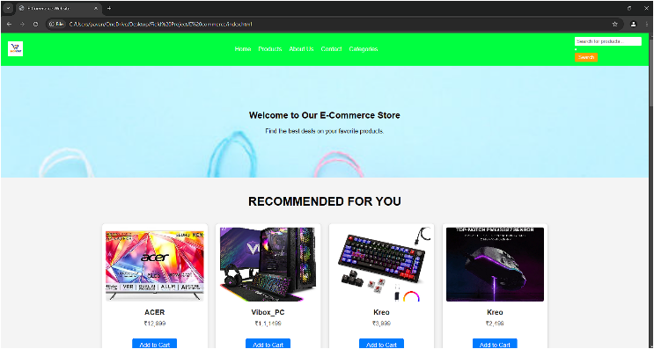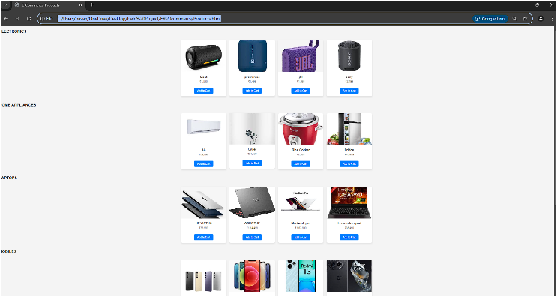

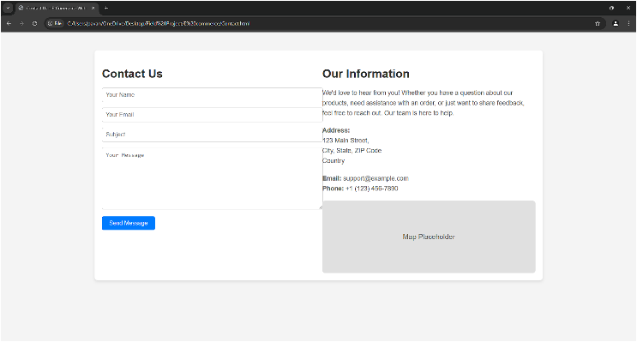

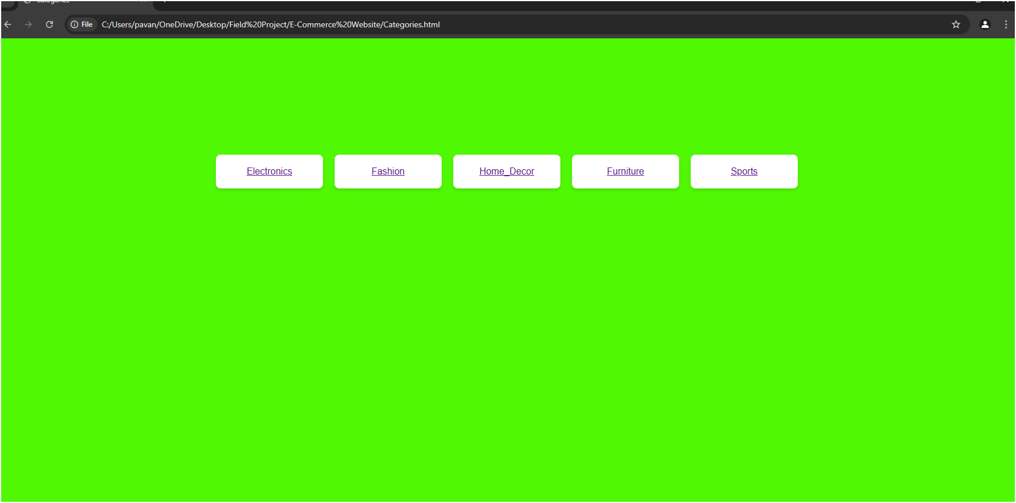

# **Conclusion**

E-Commerce has transformed the way businesses operate and consumers shop, breaking geographical barriers and offering convenience and accessibility. It enables companies to reach global audiences while providing personalized shopping experiences through advancements like AI and secure payment systems. Despite its benefits, eCommerce faces challenges, including cybersecurity risks, intense competition, and logistical hurdles.

To succeed, businesses must focus on customer trust, innovation, and efficient service delivery. Overall, eCommerce continues to redefine traditional business models, driving global economic growth and catering to the needs of modern digital consumers.

# **REFERENCES**

Real World existing

E-commerce Websites are the references to do this project like:

**Amazon:** [**https://www.amazon.com**](https://www.amazon.com)

**Flipkart:** [**https://www.flipkart.com**](https://www.flipkart.com)